***Monolithic Documentation***

**1.Launch an EC2 Instance:**

Instance Name: Monolithic

Instance Type: t2.micro

AMI: Ununtu

Security Group Configuration

->SSh(22)

->HTTP(80)

->HTTPS(443)

->MySQL(3306)

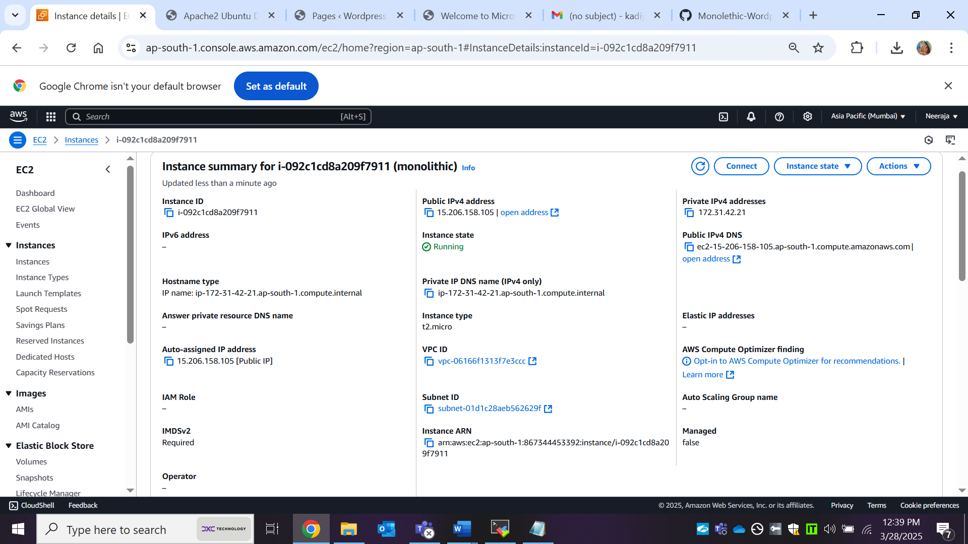

**2.Connect to the EC2 Instance**

Once the instance is running, connect via SSH or Ec2 connect or Mobaxtreme

->ssh -i key.pem ubuntu@ec2-public-ip

**3.Install Required Packages**

sudo apt update

sudo apt upgrade

sudo apt install apache2

sudo apt install php libapache2-mod-php php-mysql

sudo apt install mysql-server

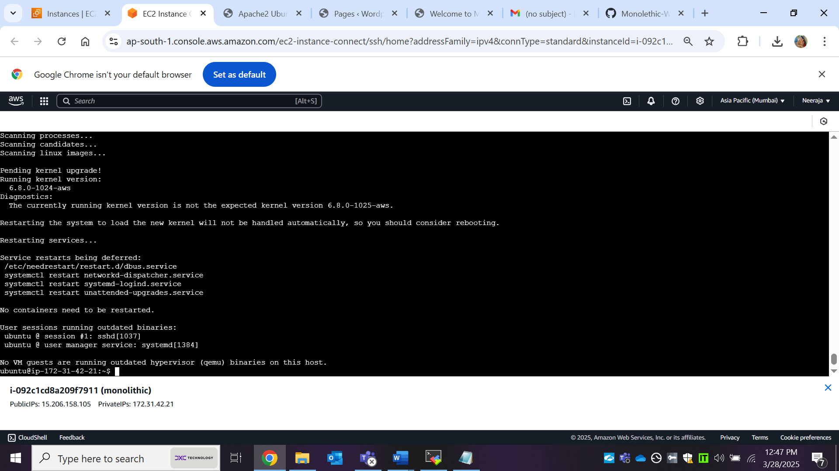

**Enable and start Apache:**

sudo systemctl enable apache2

sudo systemctl start apache2

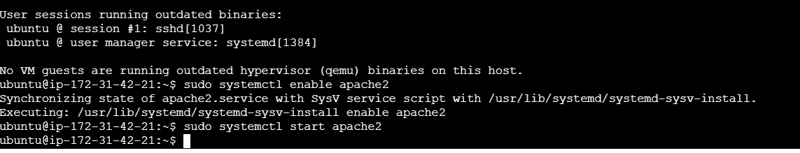

**4. Configure MySQL:**

Create a WordPress database and user:

sudo mysql -u root

CREATE USER 'wpuser'@'localhost' IDENTIFIED BY 'Password@123';

ALTER USER 'wpuser'@'localhost' IDENTIFIED WITH mysql_native_password BY 'Password@123';

CREATE DATABASE wordpress;

GRANT ALL PRIVILEGES ON wordpress.* TO 'wpuser'@'localhost';

exit;

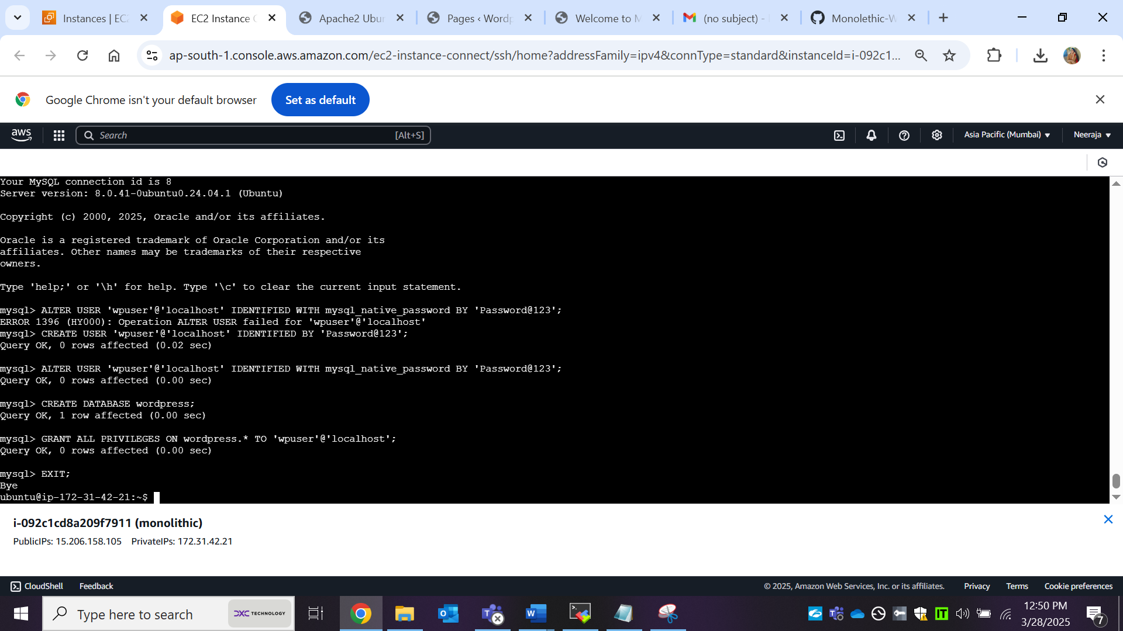

**5.Install and Configure Wordpress:**

Download and Extract WordPress:

cd /tmp

sudo wget https://wordpress.org/latest.tar.gz

sudo tar -xvzf latest.tar.gz

sudo mv wordpress/ /var/www/html

sudo systemctl restart apache2

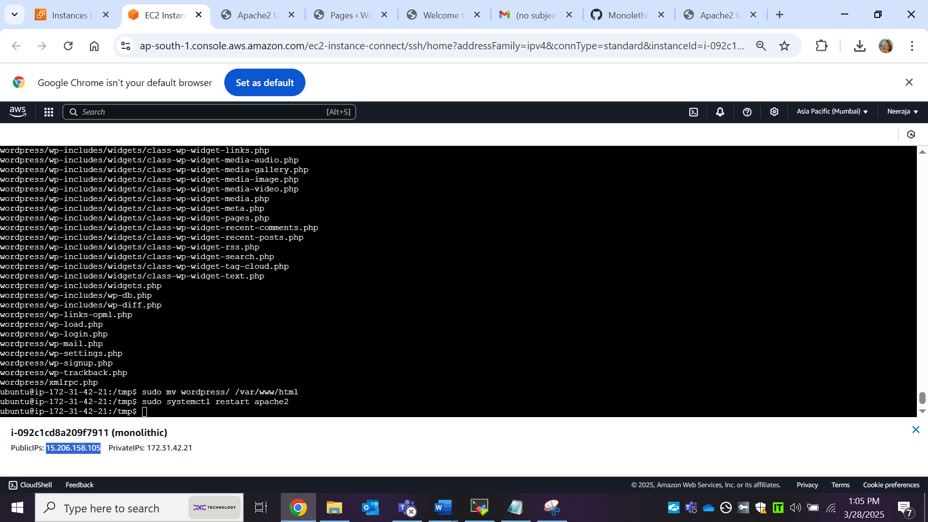

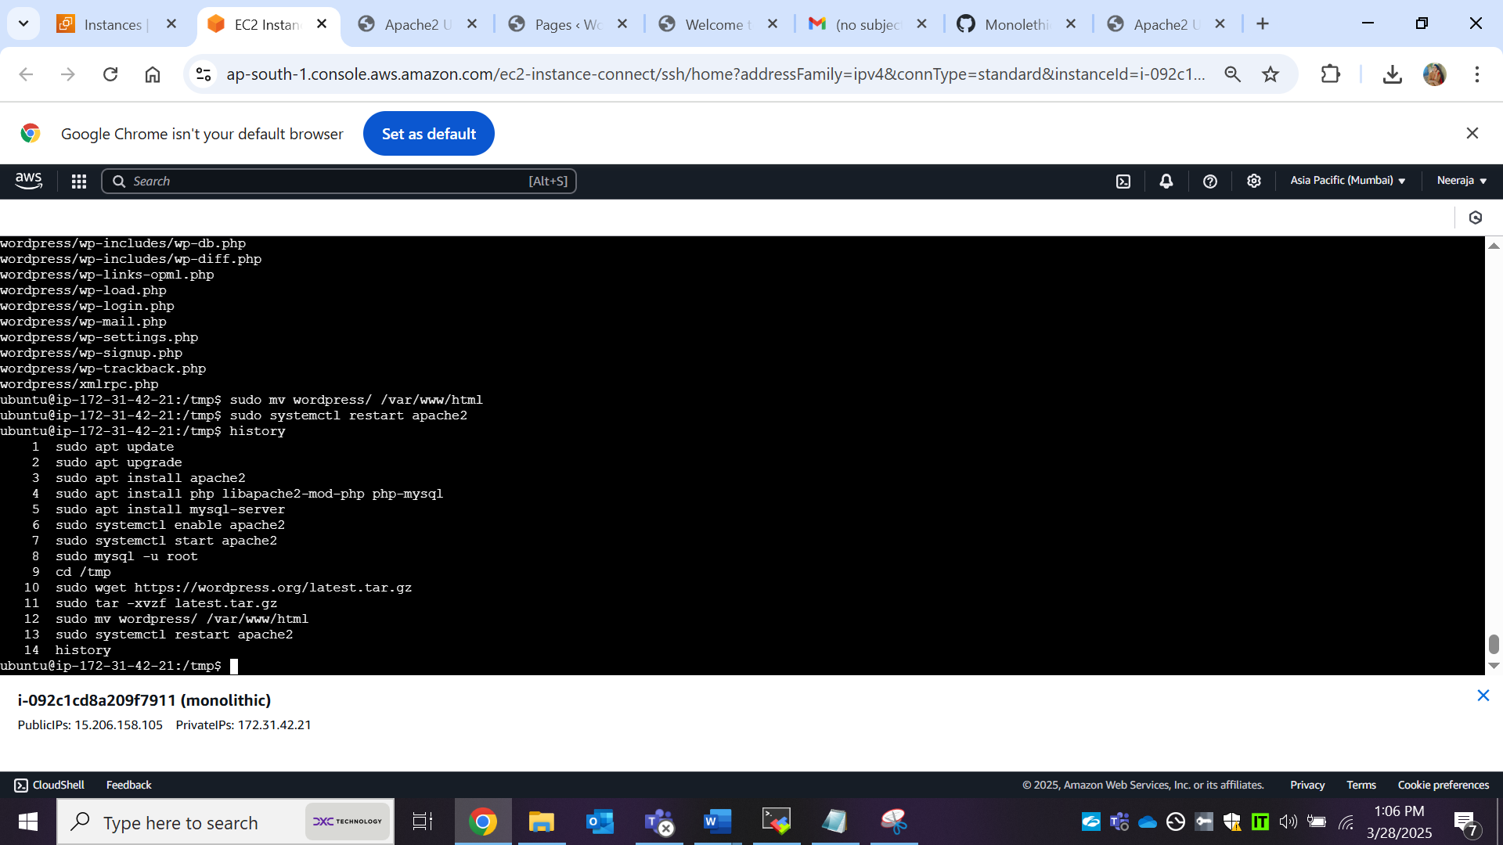

**6. Access WordPress:**

Open a browser and go to:

http://your-public-ip/wordpress/wp-admin/setup-config.php in your browser.

->Complete the Wordpress installation process.

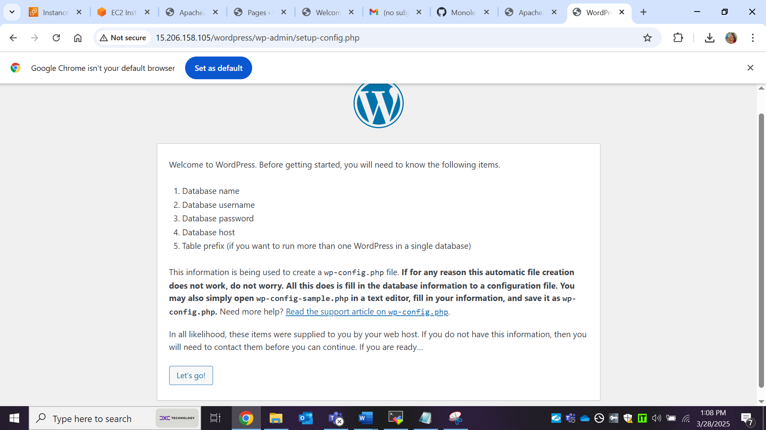

->Run the installation and config the php file inside the untar wordpress file.

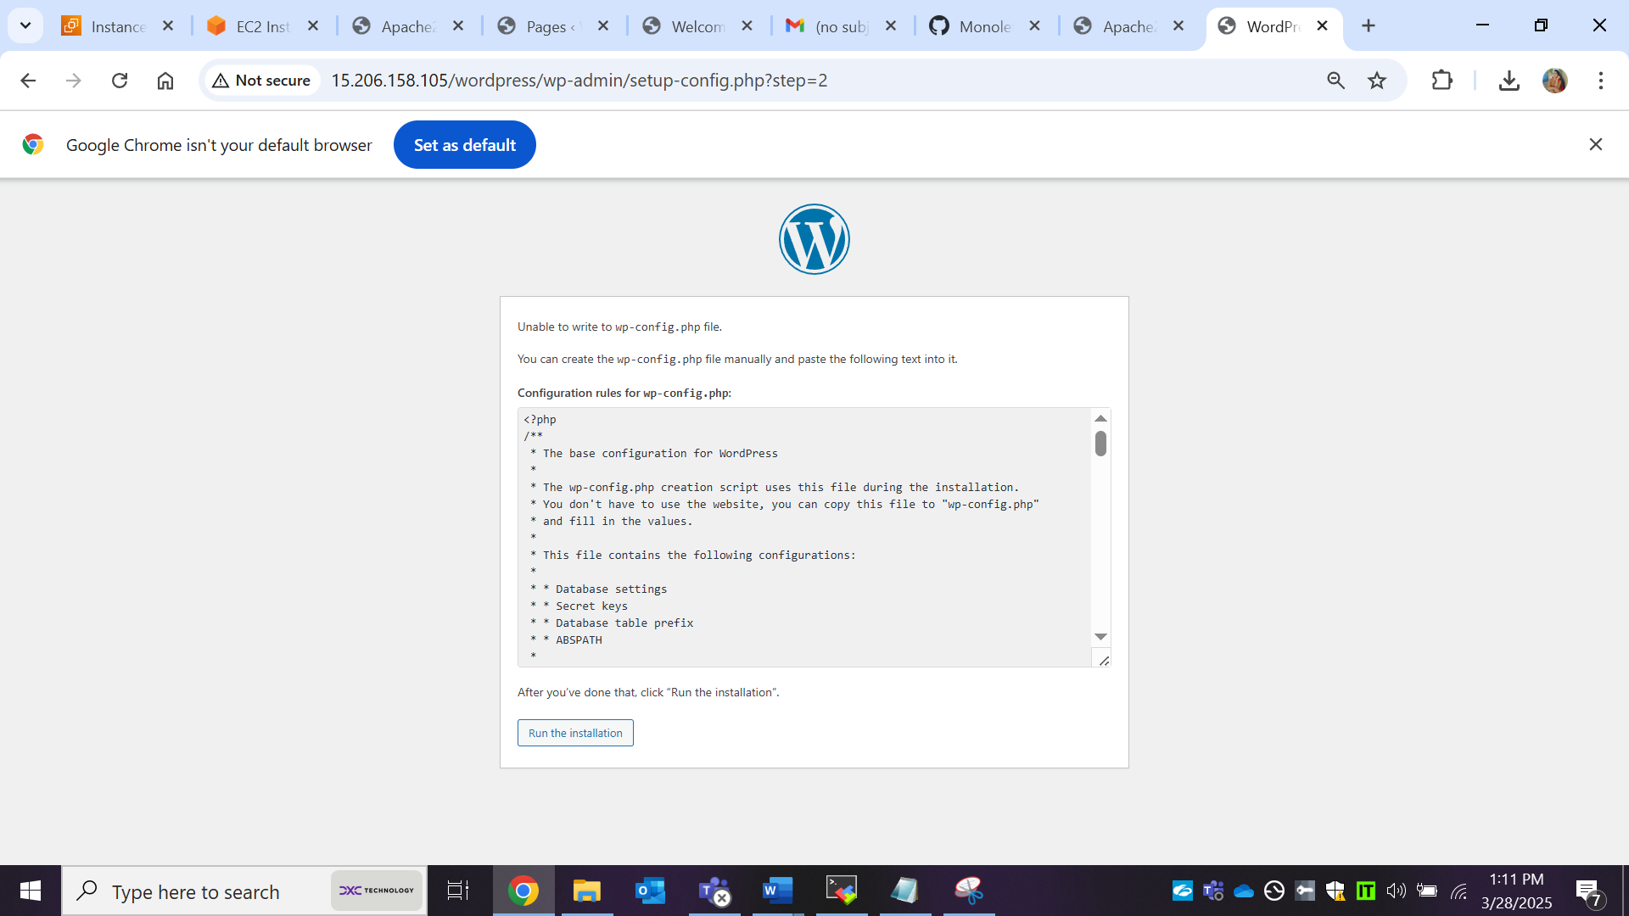

cd ..

cd /var/www/html/wordpress/

sudo vim wp-config.php

paste the content & save, exit

sudo systemctl restart apache2

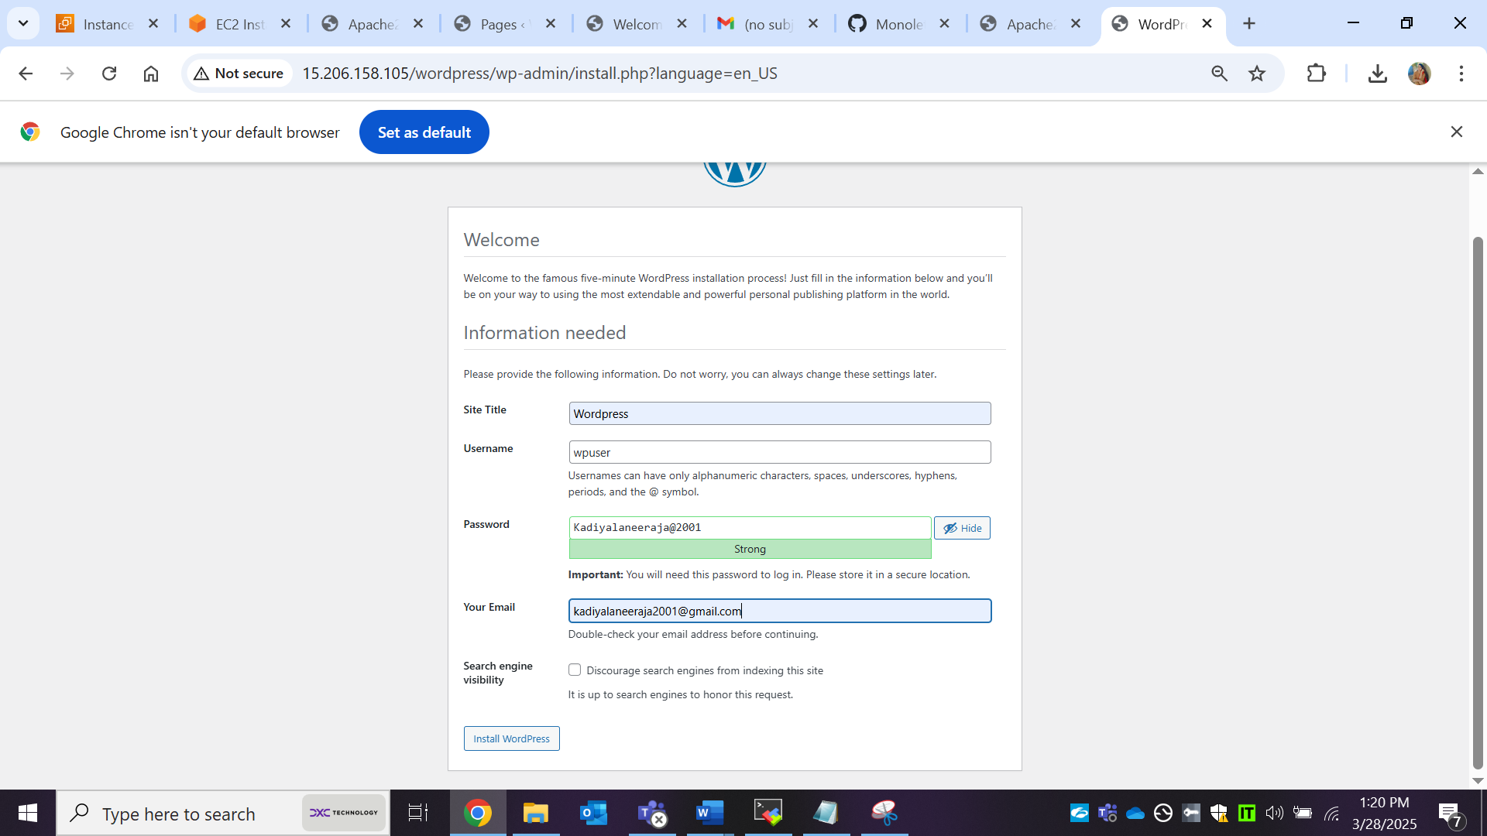

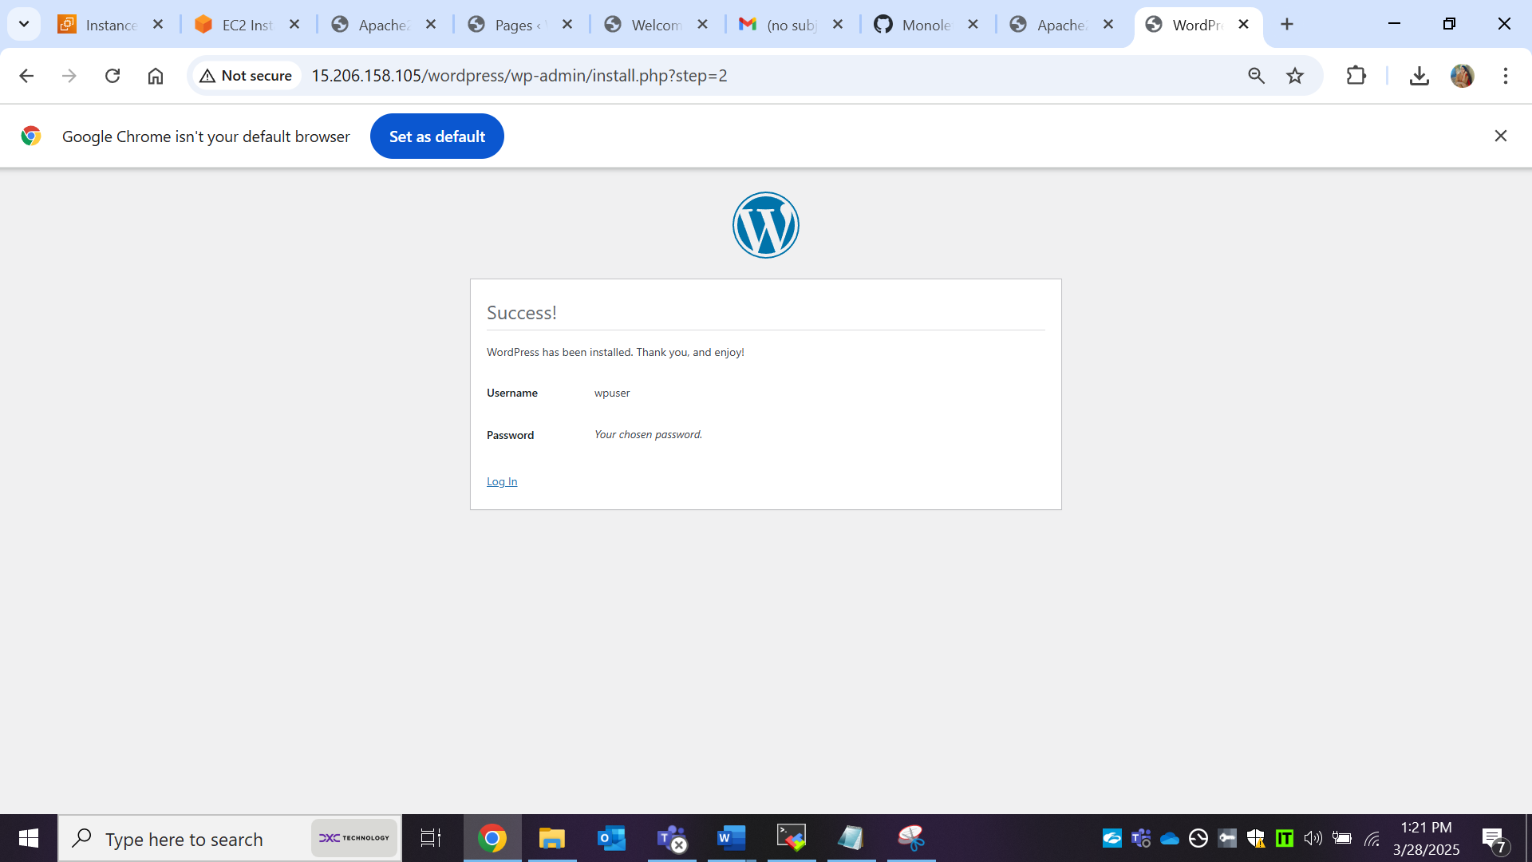

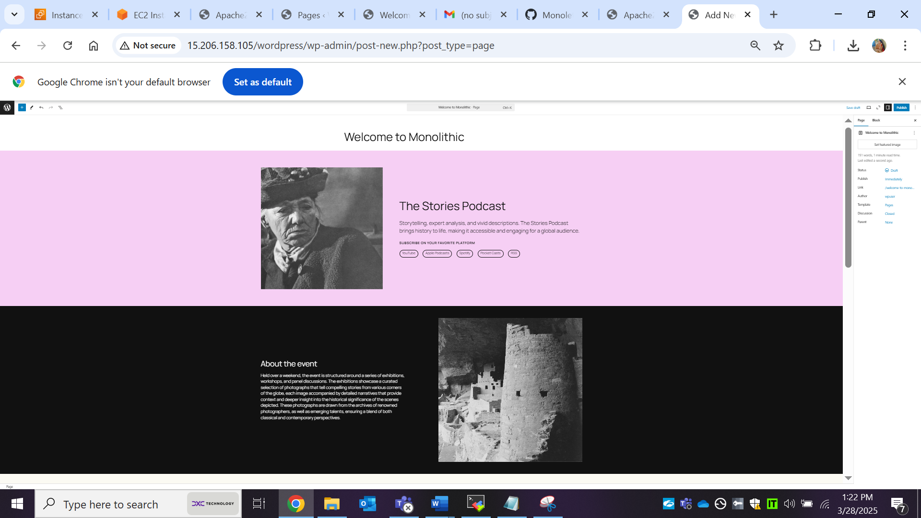

<http://15.206.158.105/wordpress/index.php/welcome-to-monolithic/>

